***MRA MILESTONE:***

***1 PROJECT***

***By: Aniket Hirgude***



***PROBLEM***

***STATEMENT***

AN AUTOMOBILE PARTS MANUFACTURING COMPANY HAS COLLECTED DATA OF

TRANSACTIONS FOR

3

YEARS. THEY DO NOT HAVE ANY IN

-

HOUSE DATA SCIENCE TEAM, THUS T

HEY HAVE HIRED YOU AS

THEIR CONSULTANT. YOUR JOB IS TO USE YOUR MAGICAL DATA SCIENCE S

KILLS TO PROVIDE THEM

WITH SUITABLE INSIGHTS ABOUT THEIR DATA AND THEIR CUSTOMERS.

AUTO SALES DATA:

SALES_DATA.XLSX



***CHECKING THE HEAD OF THE DATASET***

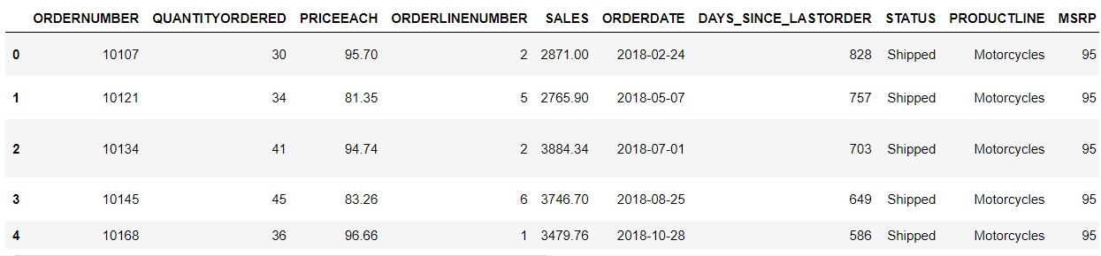

***CHECKING THE TAIL OF THE DATASET***

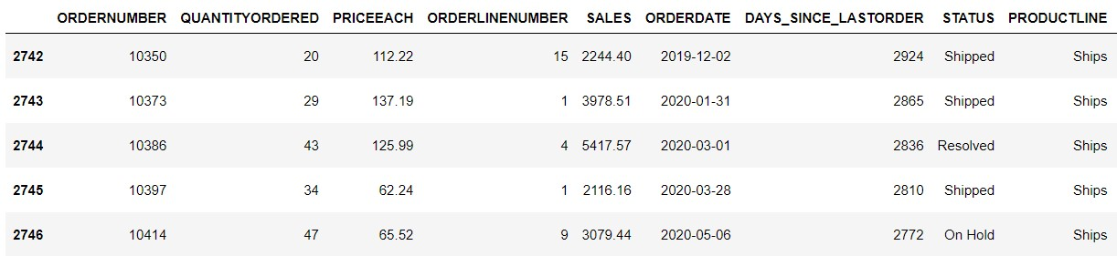

***CHECKING THE DATA TYPES***

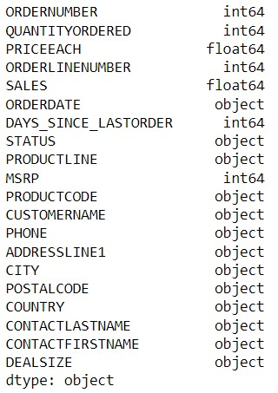

***CHECKING THE INFO OF DATASET***

FROM THE DATA SET WE SEE

THERE IS 2

FLOAT, 5 INT & 13

OBJECT VALUE ARE

PRESENT

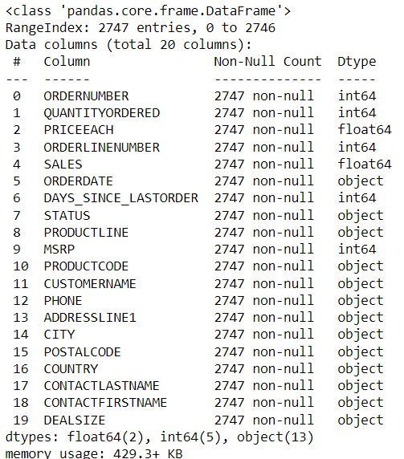

***CHECKING THE SHAPE OF THE DATA***

FROM THE DATA SET WE SEE THAT THERE ARE 2747 ROW &

20 COLUMN

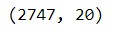



***CHECKING THE NULL VALUE***

From the data set we see

that there is no null value

present.

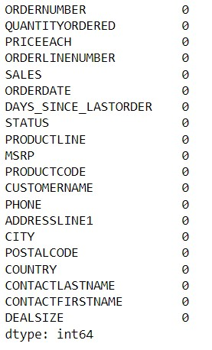

***CHECKING THE DATA DESCRIPTION***

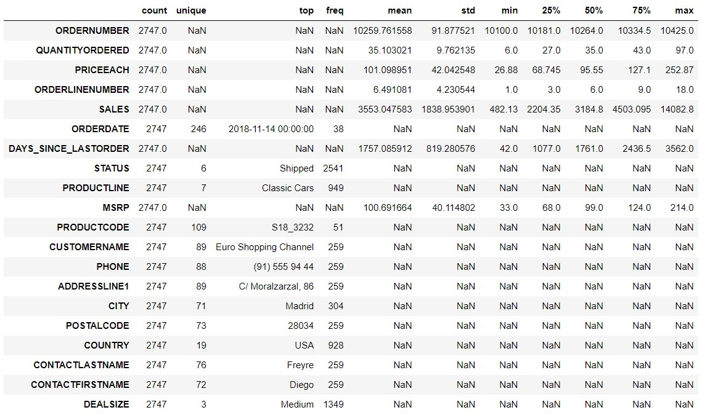

***Exploratory Analysis***

***and Inferences***

***Univariate Analysis***

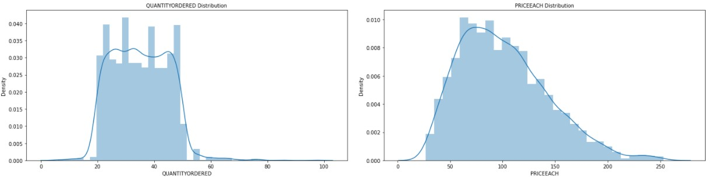

***Univariate Analysis***

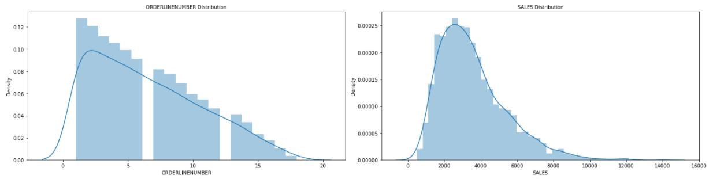

***Univariate Analysis***

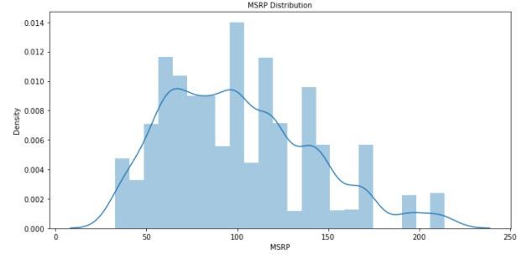

***Univariate Analysis***

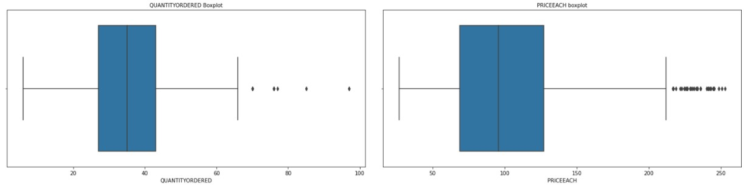

***Univariate Analysis***

ORDERNUMBER WITH SALES

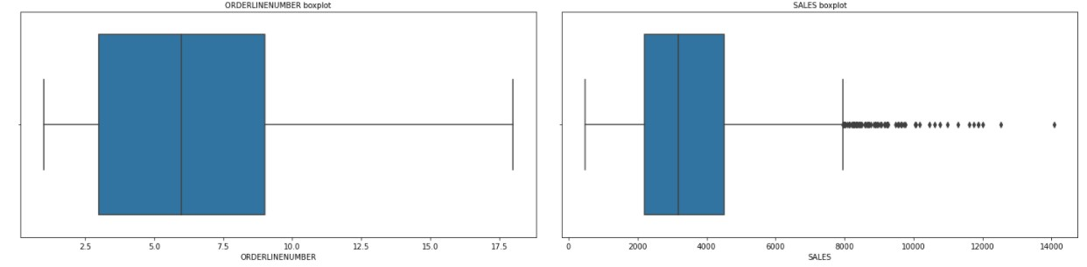

***Univariate Analysis***

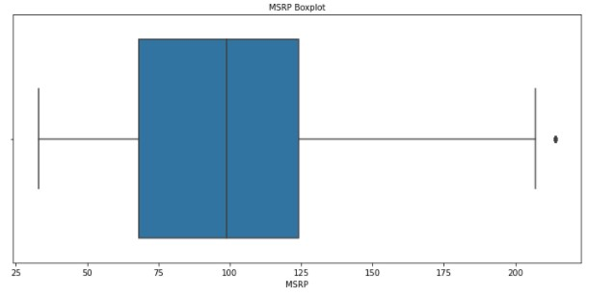

***Correlation***

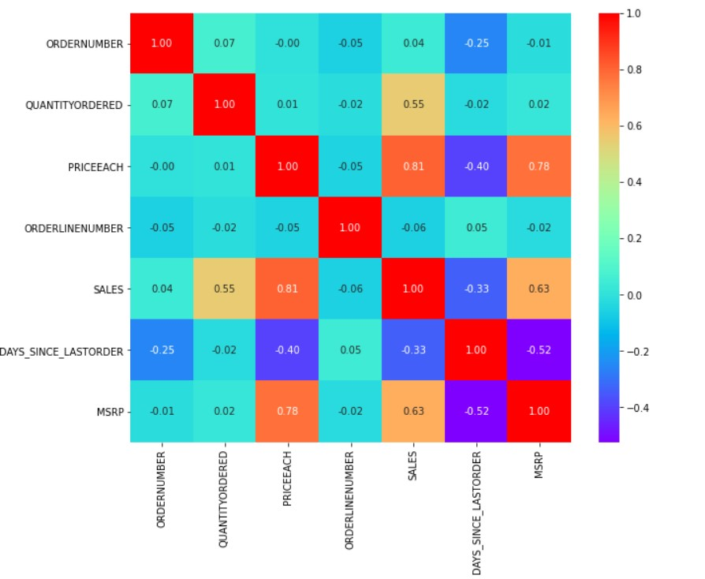

◆

Heatmap of the

Correlation Matrix:

◆

Highly Correlated

Values are:

◆

Sales & MSRP

◆

Sales & Quantity

Ordered

◆

Sales & Price Each

◆

MSRP & Price Each



***Univariate Analysis***

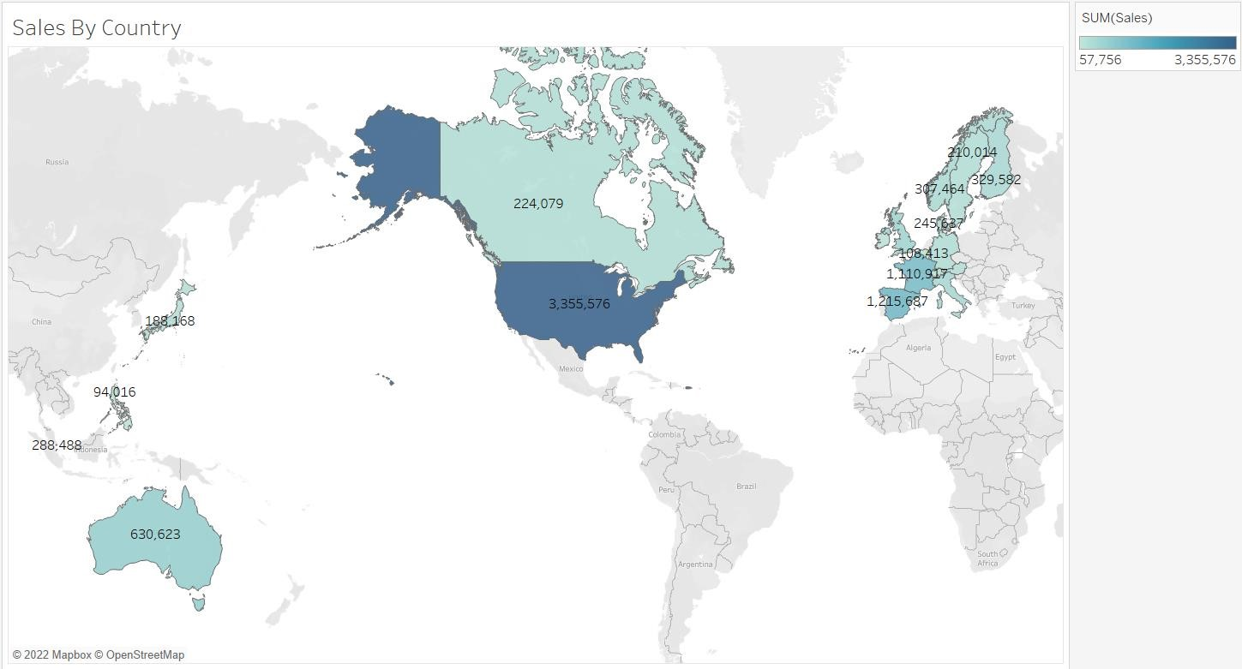

***Univariate Analysis***

DEAL SIZE

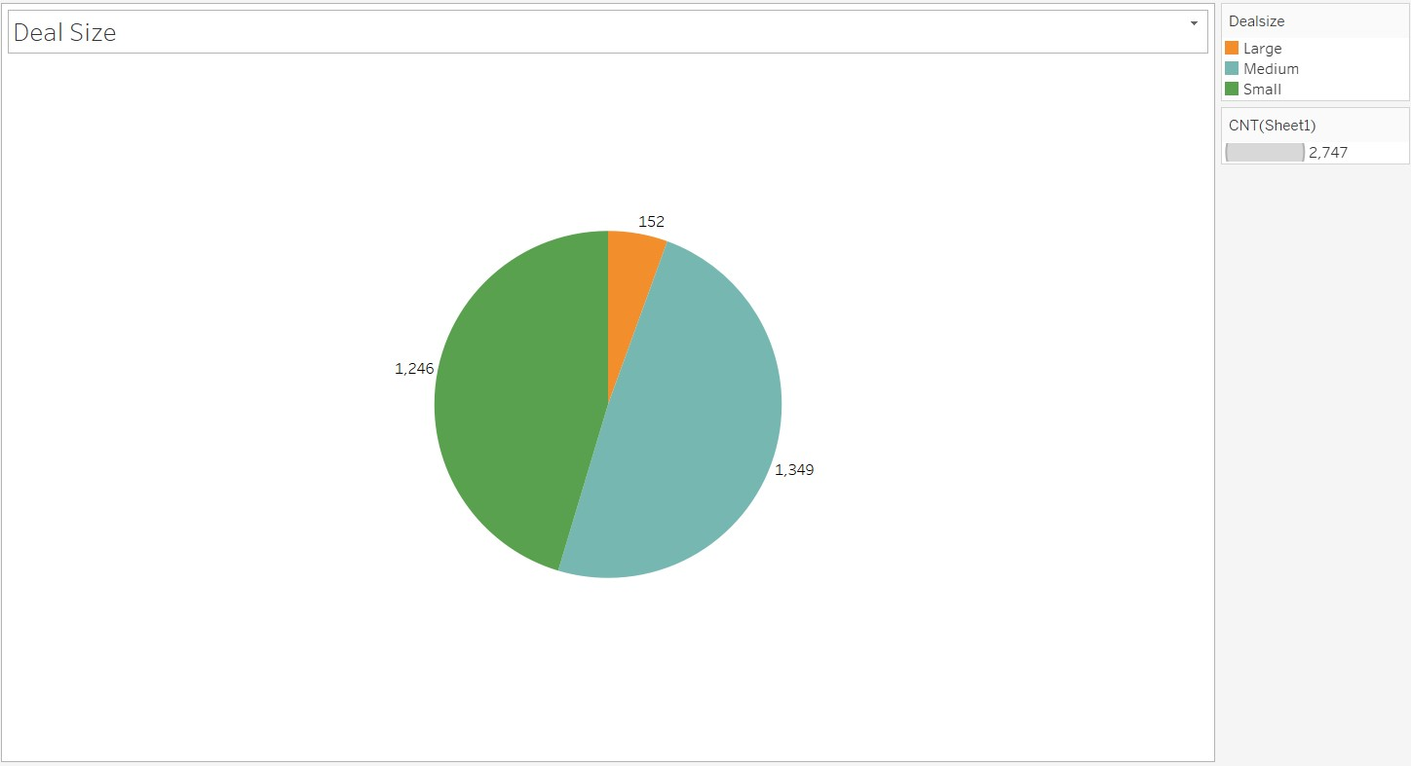

***Univariate Analysis***

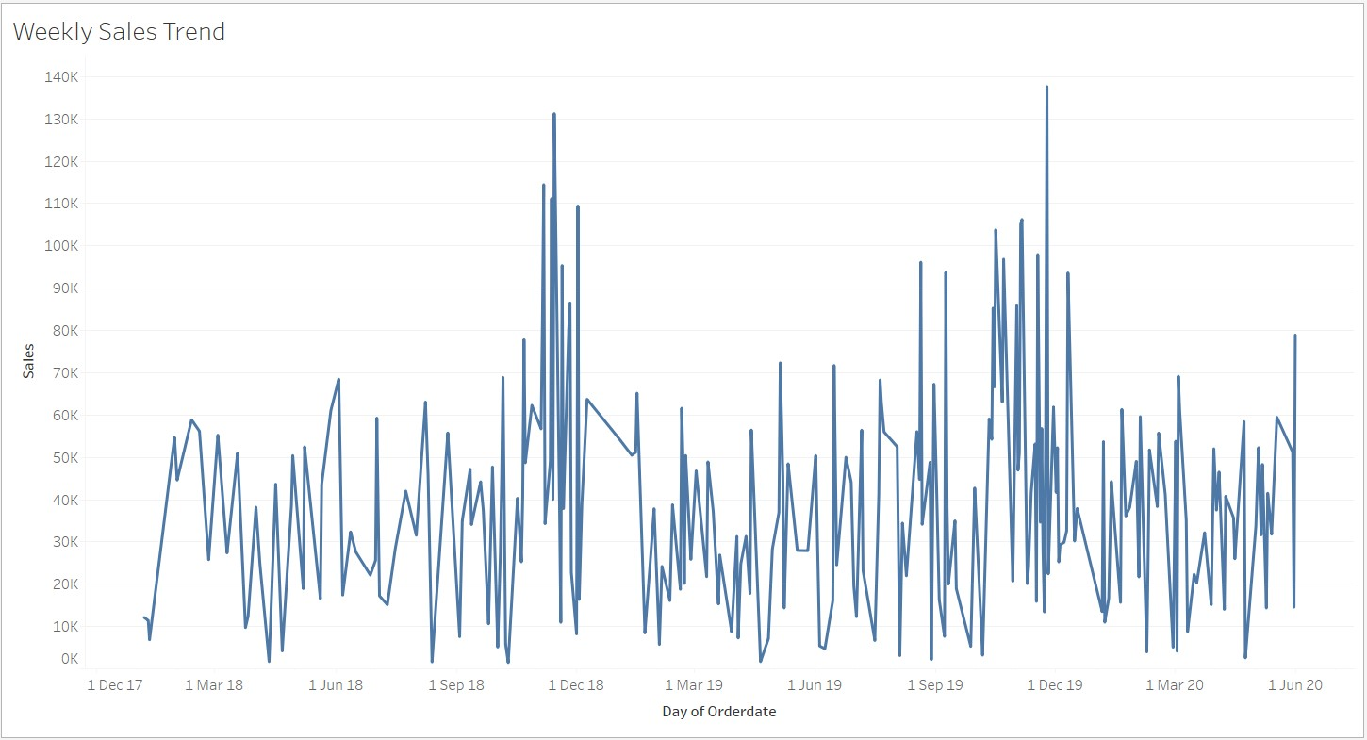

***Univariate Analysis***

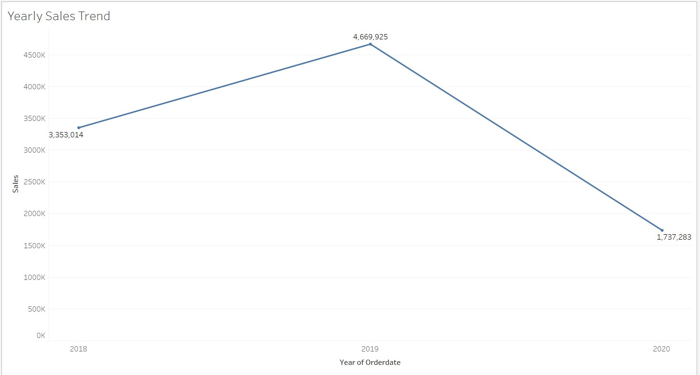

***Univariate Analysis***

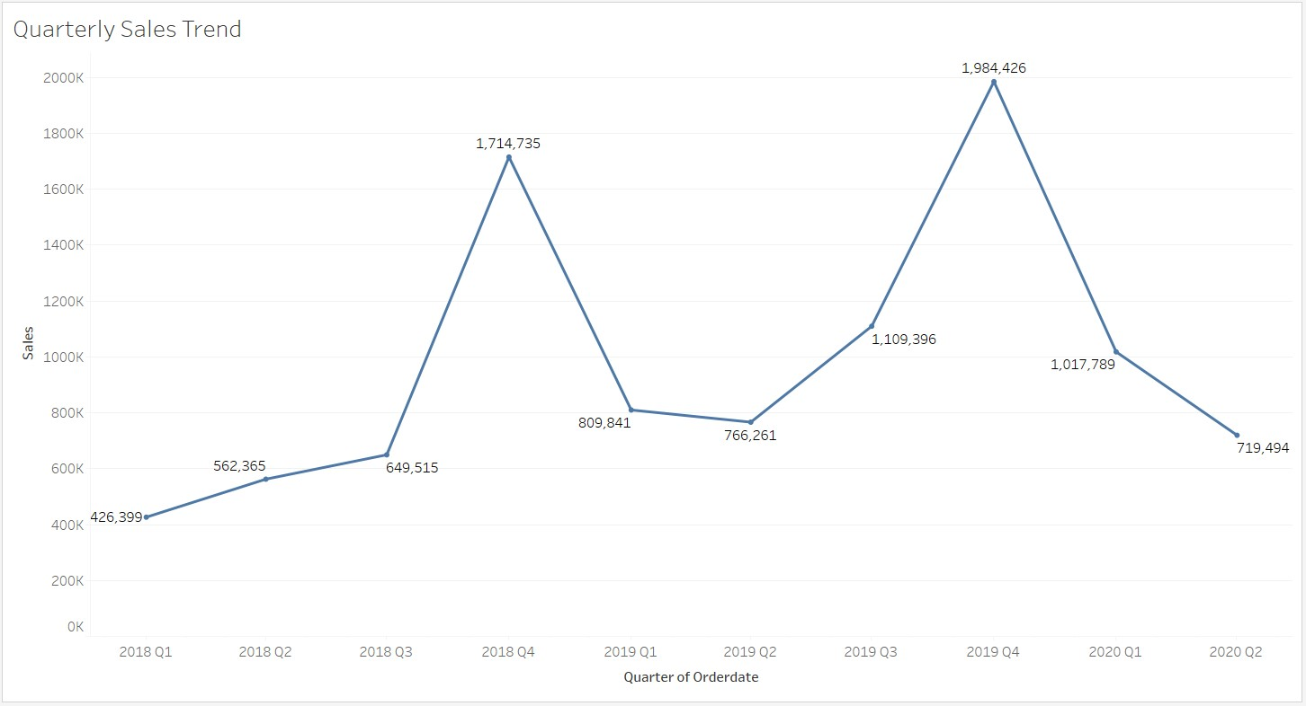

***Univariate Analysis***

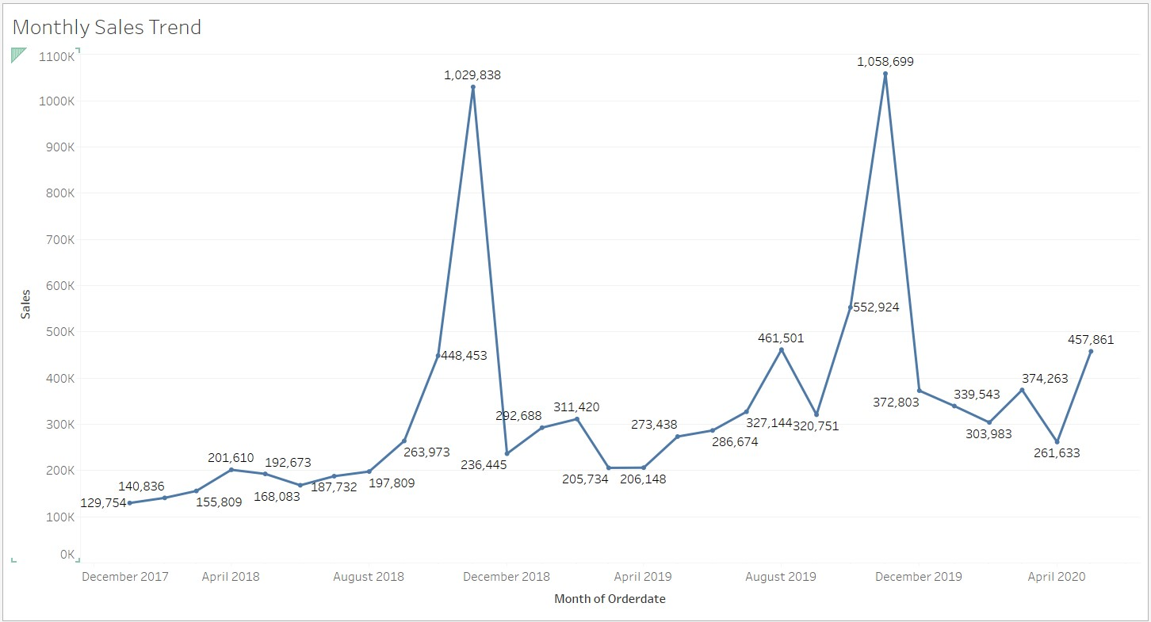

•

***Univariate Analysis***

Trend in Sales Summary

◆

November Month gives out the highest sales and week 45 fall in November

which has the highest sales as compared to other weeks.

◆

Sales

decreased

from

Q1

to Q3 and takes

a huge

rise on Q4.

◆

2019

seems to

deliver

highest sales.



***Bivariate Analysis***

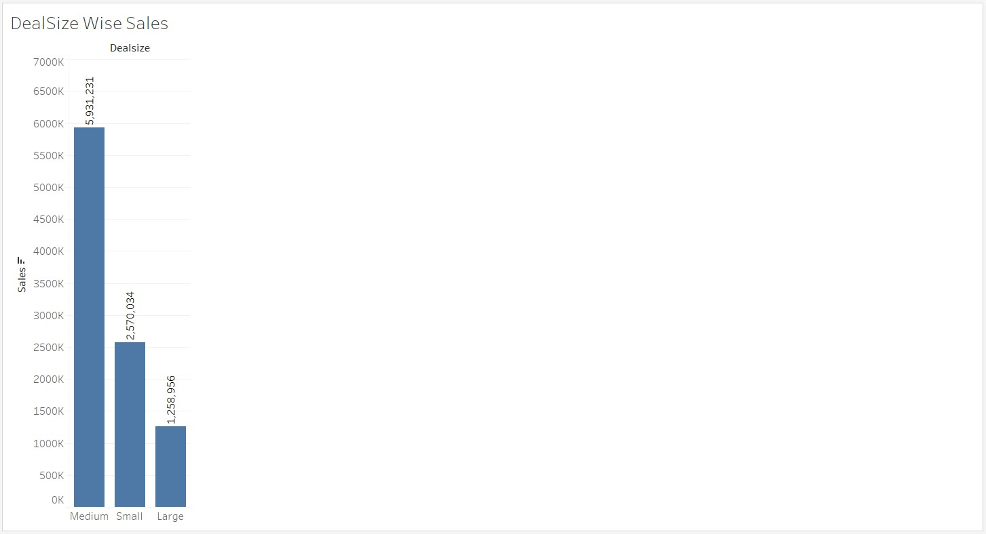

***Bivariate Analysis***

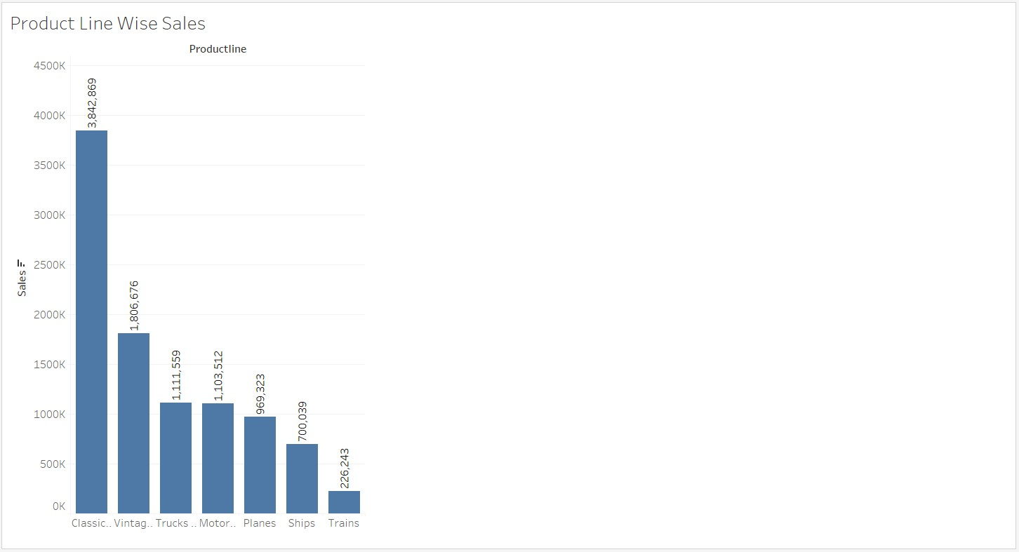

***Bivariate Analysis***

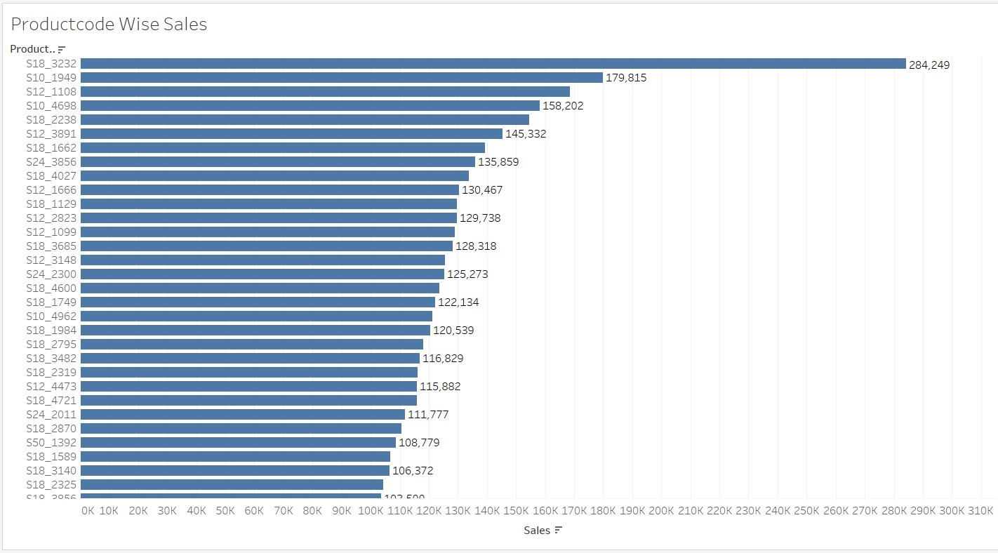

***Bivariate Analysis***

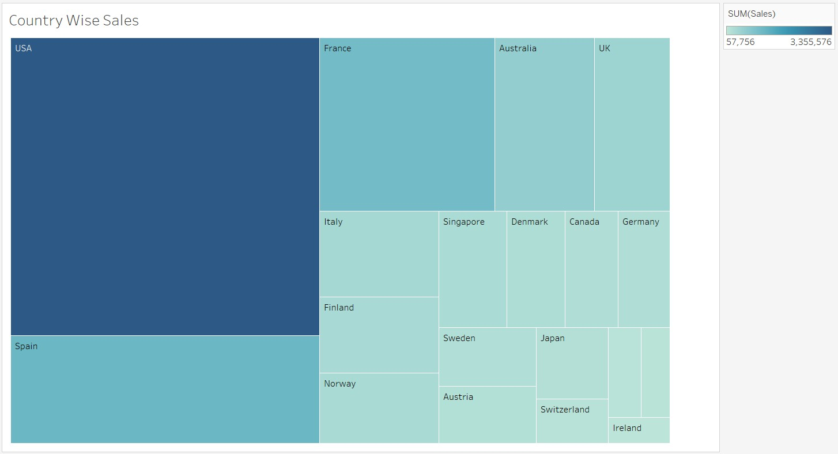

***Bivariate Analysis***

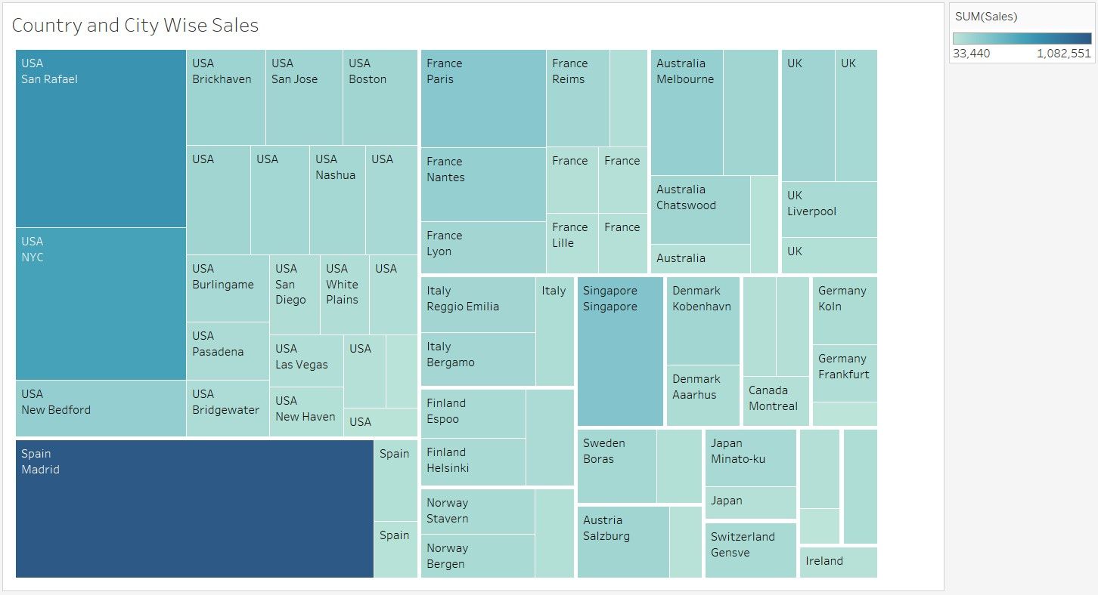

***Bivariate Analysis***

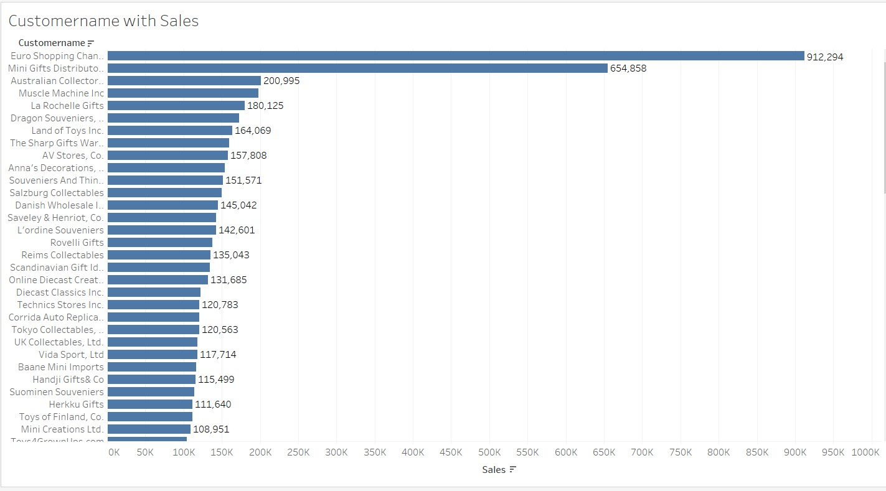

***Inferences***:



◆

USA has the Highest sales as compared to other

countries.

◆

Classic Cars

has

the highest

sales

while

Trains has the

lowest.

◆

City

Madrid in Spain has the Highest sales

when

compared to other cities.

◆

The

company

is customer driven as the

major

Revenue

is generated from

only the top 5

customers.

So the

company

must focus on more

customer

scouting as in case

of

client

churn it

will

impact the sales.

◆

Euro

Shopping

Channel

is the best customer in terms

of

Sales Amount.

◆

Medium Deal Size

deliver higher

sales than Small and

Medium.

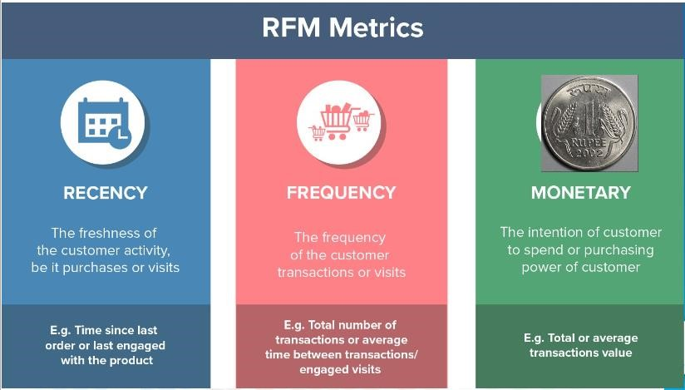

***CUSTOMER SEGMENTATION USING RFM ANALYSIS***



◆

KNIME Tool is used for RFM Analysis and customer

segmentation.

◆

Customer Name,

Quantity

Ordered, Price Each,

Order Date,

Sales are used as

parameters.

◆

RFM Model

◆

Current Date

-

Max(Order Date) is taken

as

Recency Value.

◆

Count

of Order Line Number

for a given

customer is

taken as

Frequency Value.

◆

Sales

can be

used as

Monetary

but

in this project

used the calculation of Price & Quantity.



***KNIME WORKFLOW***

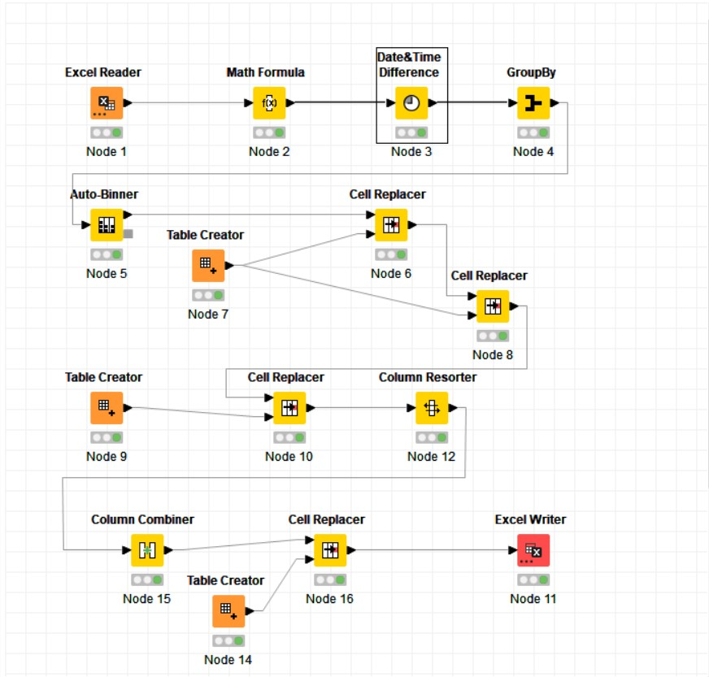

***CUSTOMER SEGMENTATION USING RFM ANALYSIS***

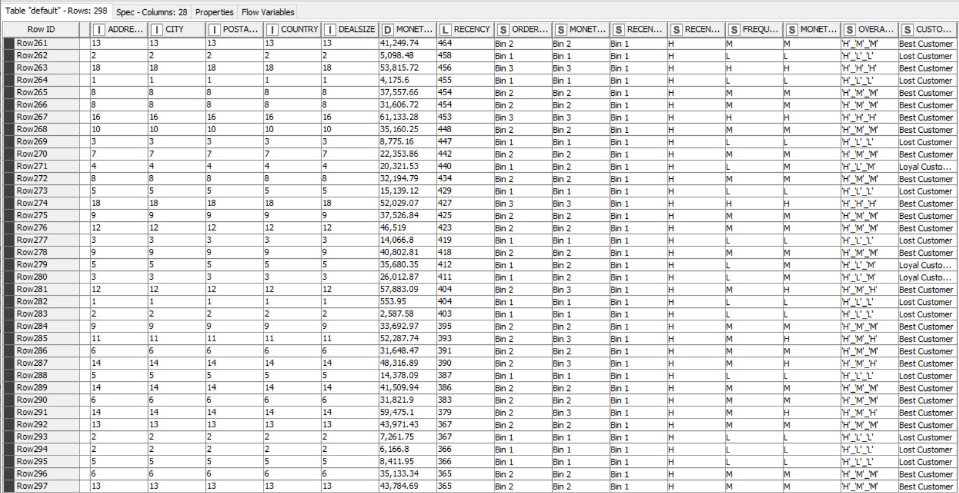

***INFERENCES FROM RFM ANALYSIS AND IDENTIFIED SEGMENTS***

◆

Best Customers

◆

Customers are on the verge of churning

◆

Lost Customers

◆

Loyal Customers



***INFERENCES FROM RFM ANALYSIS AND IDENTIFIED***

◆

Best Customers:

◆

Euro Shopping Channel

◆

Souveniers

And Things Co.

◆

Salzburg Collectables

◆

L'ordine

Souveniers

◆

La Rochelle Gifts



***INFERENCES FROM RFM ANALYSIS AND IDENTIFIED***

◆

Customers are on the verge of churning:

◆

Saveley

& Henriot, Co.

◆

Herkku

Gifts

◆

Vida Sport, Ltd

◆

Marta's Replicas Co.



***INFERENCES FROM RFM ANALYSIS AND IDENTIFIED***

◆

Lost Customers:

◆

Auto Assco. & Cie.

◆

CAF Imports

◆

Clover Collections, Co.

◆

Double Decker Gift Stores, Ltd

◆

Cambridge Collectables Co.

◆

Iberia Gift Imports, Corp.



***INFERENCES FROM RFM ANALYSIS AND IDENTIFIED***

◆

Loyal Customers:

◆

Handji Gifts & Co

◆

Tokyo Collectables,

Ltd.

◆

Auto Canal Petit.

◆

Mini Gifts

Distributors

Ltd.

◆

UK

Collectables,

Ltd.